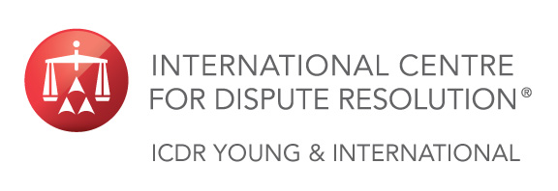 | In Cooperation With:
 | 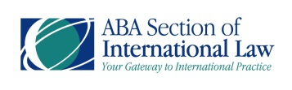 | 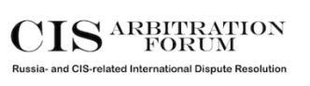
 | Present:

Resolving Small Claims Without Big Problems:

Expedited Procedures in International Arbitration and Litigation

17 SEPTEMBER 2015

Venue: | National Research University Higher School of Economics (HSE)  Myasnitskaya ul., 9, Moscow, Russia | Host:
Time: | 16:30 – Check-In Opens  17:00 - 19:00 – Seminar │ Networking Reception to Follow | Sponsor:

Opening Remarks
Kristoffer Löf  ICDR Y&I Executive Board Member; Mannheimer Swartling  Stockholm | Vladislav Starzhenetsky  National Research University Higher School of Economics  Moscow

Key Note Speech
Christopher Coffin
Withers
London

Panel Discussion
SPEAKERS:
Kabir Duggal  Baker McKenzie  New York | Maxim Kulkov  Kulkov, Kolotilov & Partners  Moscow | Miroslava Schierholz  International Centre for Dispute Resolution  New York
MODERATOR:
Andrey Zelenin
ICDR Y&I Global Advisory Board Member; Lidings
Moscow

Closing Remarks
Anna Kozmenko
ICDR Y&I Global Advisory Board Member; Schellenberg Wittmer
Zurich

Registration Form Please Print or Type Email Completed Form to: ICDR_YI_moscow@lidings.com

 | Mr. | Ms. | Mrs. | Dr.
First Name: |  |  |  |  | Last Name:
Job Title: |  |  |  |  | Company:
City: |  |  |  |  | State: |  |  |  | Country:
Telephone: |  |  |  |  | Email:

This event is free of charge and will be presented in English.

