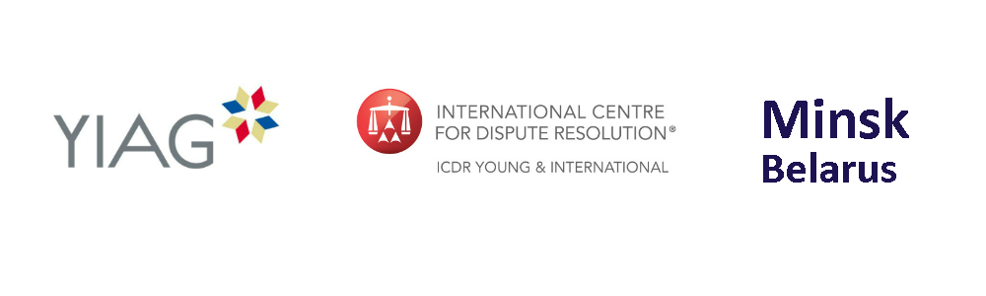
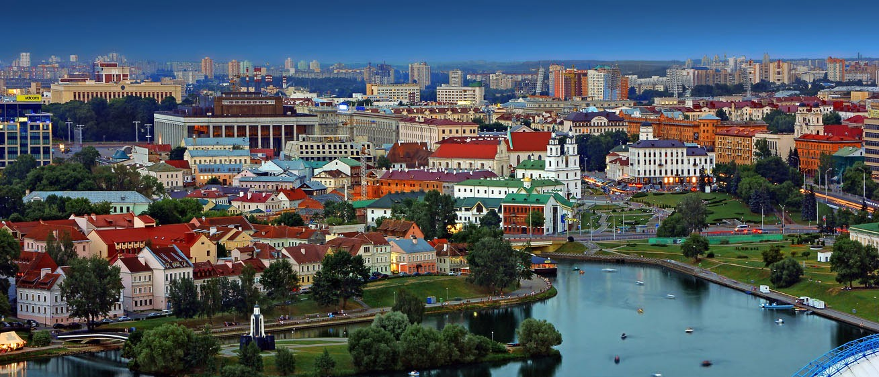
Joint YIAG and ICDR Y&I Seminar on International Arbitration

14:30, Thursday 22 September 2016

Background
The Young International Arbitration Group (YIAG) and the International Centre for Dispute Resolution Young & International (ICDR Y&I) are glad to invite you to take part in a discussion focused on the most relevant trends in the sphere of international arbitration at the Joint YIAG and ICDR Y&I Seminar on International Arbitration on 22 September 2016.
The joint YIAG and ICDR Y&I seminar will precede the first Eastern European Dispute Resolution Forum (EEDRF) to be held in Minsk on 23 September 2016.
Program of the seminar

15.00 – 16.00. Session 1: Emergency arbitrator in international arbitration: pros and cons
Moderator: Dzmitry Barouka, Ketenci, Minsk
Speakers:
- Galina Zukova, White & Case, Paris
- Pawel Pietkiewicz, Greenberg Traurig Grzesiak sp.k., Warsaw
- Artem Doudko, White & Case, London
16.00 – 17.00. Session 2: Practical aspects of handling evidence in international arbitration – a comparative experience
Moderator: Alexey Anischenko, SORAINEN, Minsk
Speakers:
- Evgeniya Rubinina, Freshfields, London
- Alexandre Khrapoutski, SBH, Minsk
- Andrey Panov, Norton Rose Fulbright, Moscow

Time and venue
The joint YIAG and ICDR Y&I seminar will take place in Renaissance Minsk Hotel (Dzerzhinsky Avenue 1 E) on 22 September 2016.
The registration for seminar will start at 14:30. The main part of the event will finish at 17.00 and will be followed by coffee, tea, snacks and networking, as well as an opportunity for participants to share and reflect upon their experiences and learning.
Language
The seminar will be held in Russian (without translation).
Participation cost
The participation in the seminar is free of charge due to the generous support of our partners.
The event is organized in partnership with:
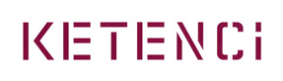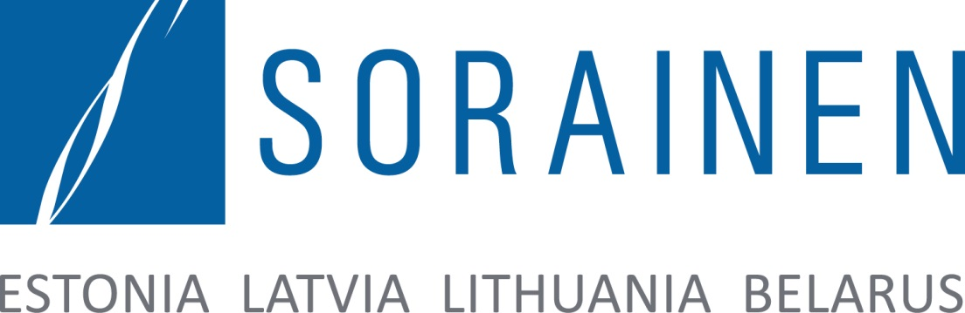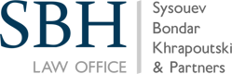

Please RSVP at liudmila.belkovich@sorainen.com

